STRUCTURING THE DIGITAL TWIN: USING SITES V2 AS A DATA ARCHITECTURE FOR CAMPUS LANDSCAPES

ABSTRACT
Digital twin concepts are gaining traction in landscape architecture, but the field lacks repeatable guidance on what baseline data to collect and how to structure those data for performance-based design. This paper documents the data architecture phase of the Aggie Virtual Architect (AVA) project at North Carolina Agricultural and Technical State University (NC A&T), an Evans-Allen-funded initiative that developed a digital twin foundation for the Holland Bowl, a campus landscape with persistent turf failure and high maintenance costs. We treat the Sustainable SITES Initiative (SITES v2) rating system not as a post hoc evaluation tool but as the organizing schema for data acquisition, specifying baseline datasets required to support pre-design assessment and targeted performance outcomes. Six geospatial data streams were integrated: UAV imagery, a facilities CAD survey basemap, AI-derived planimetrics, USGS elevation data, NRCS soils data, and field reconnaissance. Cross-source triangulation revealed that the site substrate is mapped as Urban Land (anthropogenic fill), a finding with direct implications for soil and vegetation performance assumptions. Field reconnaissance further identified a subsurface steam corridor not detectable via remote sensing, underscoring the need for mixed-method ground-truthing even in data-rich workflows. An interdisciplinary team conducted field verification of soils, vegetation, and hardscape surfaces to establish quantitative SITES v2 baselines. The paper contributes a SITES-structured workflow for constructing landscape digital twin baselines that can be replicated on institutional or community sites to support performance-based design.

Keywords
Landscape Digital Twin, SITES v2, UAV Photogrammetry, Campus Landscapes, Data Architecture

STRUCTURING THE DIGITAL TWIN: USING SITES V2 AS A DATA ARCHITECTURE FOR CAMPUS LANDSCAPES

ABSTRACT
Digital twin concepts are gaining traction in landscape architecture, but the field lacks repeatable guidance on what baseline data to collect and how to structure those data for performance-based design. This paper documents the data architecture phase of the Aggie Virtual Architect (AVA) project at North Carolina Agricultural and Technical State University (NC A&T), an Evans-Allen-funded initiative that developed a digital twin foundation for the Holland Bowl, a campus landscape with persistent turf failure and high maintenance costs. We treat the Sustainable SITES Initiative (SITES v2) rating system not as a post hoc evaluation tool but as the organizing schema for data acquisition, specifying baseline datasets required to support pre-design assessment and targeted performance outcomes. Six geospatial data streams were integrated: UAV imagery, a facilities CAD survey basemap, AI-derived planimetrics, USGS elevation data, NRCS soils data, and field reconnaissance. Cross-source triangulation revealed that the site substrate is mapped as Urban Land (anthropogenic fill), a finding with direct implications for soil and vegetation performance assumptions. Field reconnaissance further identified a subsurface steam corridor not detectable via remote sensing, underscoring the need for mixed-method ground-truthing even in data-rich workflows. An interdisciplinary team conducted field verification of soils, vegetation, and hardscape surfaces to establish quantitative SITES v2 baselines. The paper contributes a SITES-structured workflow for constructing landscape digital twin baselines that can be replicated on institutional or community sites to support performance-based design.

Keywords
Landscape Digital Twin, SITES v2, UAV Photogrammetry, Campus Landscapes, Data Architecture

INTRODUCTION
Landscape architecture increasingly requires approaches that connect design decisions to measurable outcomes and remain legible to non-specialist stakeholders. Digital twin concepts offer a potential bridge between computational modeling and real-world decision-making (Batty, 2018; Grieves, 2014; Shahat et al., 2021). The National Academies of Sciences, Engineering, and Medicine (NASEM, 2024) defines a digital twin as a set of virtual information constructs that mimic a system’s structure, context, and behavior to inform decisions—a definition applicable to landscape systems despite their biological complexity, temporal dynamics, and social dimensions.
What is missing from the emerging landscape digital twin literature is not the aspiration but the method: a structured framework for determining what data to collect, what performance criteria should organize that collection, and how the resulting data environment can serve both applied planning and pedagogical purposes. Existing efforts tend to collect data opportunistically rather than against a defined performance standard (Biljecki et al., 2015). This paper addresses that gap by documenting a workflow in which the SITES v2 (Green Business Certification Inc. [GBCI], 2014) rating system serves as the organizing schema for a campus landscape digital twin, determining both the scope and structure of the data architecture.

Theoretical Framework
Donald Schön’s (1983) theory of reflective practice provides the theoretical grounding for this work. Schön frames design as a “reflective conversation with a situation” in which designers receive feedback from the environment and use that feedback to reframe problems and generate new design moves (Schön, 1983). The SITES v2 rating system operationalizes this framework: when a student proposes a design intervention and the SITES scoring engine evaluates it against quantifiable ecological standards, the system reproduces the essential structure of Schön’s reflective cycle in a computational context. Phase 1 constructs the data foundation—the structured representation of the situation—that makes this reflective exchange possible in Phase 2. The adoption of Public Participation GIS (PPGIS) principles (Ramirez Aranda et al., 2023) extends Schön’s reflective conversation to include the situated knowledge of campus users, broadening both the data foundation and the range of feedback the system can provide.

Research Context
The research is supported by the Evans-Allen Program of the USDA National Institute of Food and Agriculture (USDA NIFA, n.d.), which provides capacity-building funding for food and agricultural research at 1890 land-grant historically Black colleges and universities (HBCUs). The Evans-Allen mandate aligns directly with the project’s goal of integrating advanced geospatial technologies—including UAV operations, GIS, and digital twin construction—into landscape architecture education at NC A&T.

Research Objectives
The Evans-Allen research plan identifies two overarching objectives: (1) to test the potential for a digital twin to improve sustainable landscape management practices, and (2) to develop the digital twin as a pedagogical tool for landscape architecture education. The specific research questions are:
(a) What data streams are required to construct a landscape digital twin foundation sufficient to support SITES v2 performance evaluation?
(b) How does the SITES v2 framework function as an organizing schema for data collection—determining what to collect, where, and at what resolution?
(c) What site characteristics emerge from cross-source data integration that were not apparent from any single data source?

Background and Literature Review

Digital Twins in Landscape Contexts
Prior digital twin scholarship emphasizes linking a physical system to a digital representation that can support decision-making, scenario testing, and communication (Grieves, 2014; Batty, 2018). However, landscape systems complicate this model because ecological dynamics, management regimes, and social use patterns are difficult to represent through a single sensing modality. Shahat et al. (2021) reviewed city digital twin potentials, identifying integration challenges that apply equally to site-scale landscape systems. In landscape contexts, work on semantic richness and dataset accuracy suggests that the usefulness of a site-scale twin depends less on novelty of tools and more on methodical baseline data integration (Biljecki et al., 2015; Han et al., 2023). The evolution of digital tools in landscape architecture education—from CAD to immersive virtual reality—has similarly required careful calibration between digital capability and design learning outcomes (Sleipness & George, 2017; Summerlin et al., 2024).

UAV Photogrammetry in Landscape Research
UAV photogrammetry has become a practical method for capturing high-resolution 3D landscape data at site scales relevant to design and planning (Colomina & Molina, 2014). George and Park (2020) document the integration of drones into landscape architecture curricula, finding that students develop enhanced spatial awareness and site analysis skills. Weber (2024) demonstrates how mobile LiDAR and thermal imaging extend documentation capabilities. The complementarity of photogrammetric platforms—visual fidelity from mesh-based processors and survey-grade accuracy from photogrammetric calibration with ground control points (GCP) integration—is essential for landscape digital twins that must serve both design exploration and spatial analysis (Colomina & Molina, 2014).

SITES v2 as Performance Framework
The Sustainable SITES Initiative emerged from a recognition that while LEED had transformed building design practice, no equivalent performance standard existed for surrounding landscapes (Calkins, 2012). SITES v2, released in 2014 under the administration of Green Business Certification Inc. (GBCI), operates on a 200-point scale organized across ten thematic sections. The system includes 18 mandatory prerequisites and 48 optional credits, with certification awarded at four tiers from Certified (70 points) through Platinum (135+ points) (GBCI, 2014). For the AVA project, SITES provides a field-specific performance framework that can structure site documentation before design begins, making it suitable as a schema for baseline data requirements.

METHODS

Study Site
The Holland Bowl is a campus landscape feature at NC A&T State University in Greensboro, North Carolina, bounded by academic and residential buildings on three sides and a primary campus circulation spine to the north (Figure 1). The Bowl occupies a topographically low position in the campus drainage network and functions as an intramural and event field. NC A&T Facilities Management identified the Holland Bowl as a high-priority site for intervention based on persistent turf failure in the lower bowl (J. S. Martin, personal communication, June 30, 2025), high annual maintenance expenditures (e.g., a standard maintenance cycle for the 2.04-acre site requires a 5-person crew and 70 minutes of active labor) (J. S. Martin, personal communication, June 26, 2025), and the presence of a subsurface steam vent corridor complicating planting establishment.
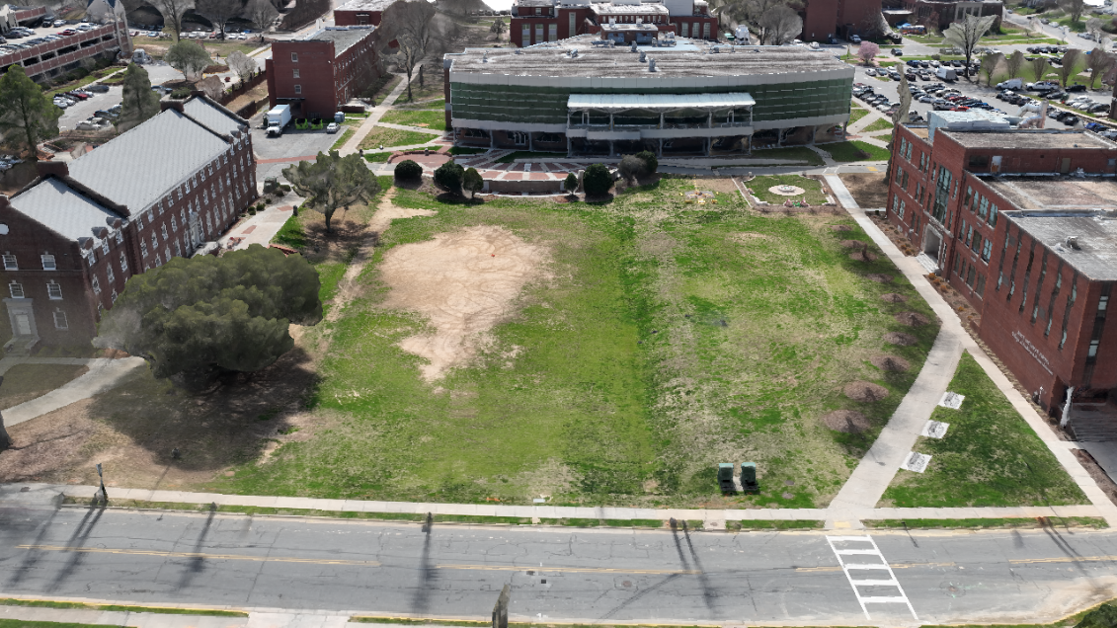
Figure 1. Aerial view of the Holland Bowl at NC A&T State University. The concave topography and intensive use patterns are visible. Source: Drone images taken by the authors.

SITES v2 as Organizing Framework for Data Collection
The research team used SITES v2 not merely as an evaluation tool applied after data collection, but as the organizing schema that determined what data to collect, where, and at what resolution. Of the ten SITES v2 sections, the Evans-Allen research plan operationalizes criteria from four sections selected because they translate effectively into a digital interface and address the Holland Bowl’s primary challenges. Table 1 summarizes these sections and their data requirements.
Table 1. SITES v2 Sections Operationalized in AVA and Corresponding Data Requirements.
SITES Section | Key Prerequisites/Credits | Required Baseline Data | Data Source
Section 2: Pre-Design Assessment | P2.2 Pre-Design Site Assessment; P2.3 Designate VSPZs | Spatial mapping of existing conditions, utilities, subsurface constraints; soil health and vegetation value | CAD basemap; NRCS soils; field reconnaissance
Section 3: Water Management | C3.1 Manage Precipitation on Site | Pervious/impervious ratio; topographic drainage patterns; stormwater infrastructure condition | UAV imagery; Ecopia planimetrics; field reconnaissance
Section 4: Soil and Vegetation | P4.1 Soil Management Plan; P4.2 Control Invasives; C4.8 Optimize Biomass | Soil classification and substrate condition; species inventory with health assessment; invasive species presence | NRCS soils; vegetation recon; georeferenced photo survey
Section 6: Human Health & Well-Being | C6.3 Equitable Site Development; C6.4 Mental Restoration | Spatial distribution of amenities; accessibility audit; pedestrian circulation patterns | Field reconnaissance; CAD basemap; photo survey

Data Collection and Integration
Phase 1 integrated six baseline datasets. UAV flights were conducted using a DJI Matrice 350 RTK platform with a target ground sampling distance of approximately 1–2 cm under Federal Aviation Administration (FAA) Part 107 rules (Small Unmanned Aircraft Systems, 2016). Ground control points were established using a Trimble dual-frequency GNSS receiver in RTK mode.
Table 2. Baseline Data Streams Integrated into the Holland Bowl Digital Twin.
Data Stream | Source | Resolution/ Accuracy | SITES Alignment | Status
UAV Photogrammetric Survey | DJI Matrice 350 RTK + Trimble GNSS | 1–2 cm GSD; RTK ground control | Sections 2, 3, 4 | Captured; processing summer 2026
CAD Survey Basemap | NC A&T Facilities Management | Survey-grade | Sections 2, 6 | Integrated
Ecopia AI Planimetrics | Ecopia Tech Inc. | >95% geometric accuracy | Section 3 | Integrated
USGS 3DEP Elevation Data | USGS | 1-meter DEM | Sections 2, 3 | Integrated
NRCS Web Soil Survey | USDA-NRCS | Map-unit level | Sections 2, 4 | Integrated
Georeferenced Photo Recon | Google Pixel 10 (74 images) | GPS-tagged | Sections 3, 4, 6 | AI-processed
CAD Survey Basemap. An existing CAD basemap from NC A&T Facilities Management encodes boundary information, utility locations (including the steam vent corridor), stormwater infrastructure, and building footprint geometry. Data were reprojected to NAD83 / North Carolina State Plane (US feet).
Ecopia AI Planimetrics. AI-derived vector data provide 2D and 3D land cover classifications across the campus with reported >95% geometric accuracy (Ecopia AI, n.d.), extending the impervious surface inventory beyond the UAV survey footprint for watershed-scale analysis.
USGS 3DEP Elevation Data (U.S. Geological Survey [USGS], n.d.). Lidar-derived digital elevation models at 1-meter resolution provide regional terrain context and an independent accuracy reference for photogrammetric products.
NRCS Web Soil Survey (USDA Natural Resources Conservation Service [NRCS], n.d.). USDA soil data provide subsurface characteristics including texture, permeability, and ecological suitability classifications essential for SITES soil and vegetation scoring.
Georeferenced Photo Reconnaissance. On April 1, 2026, a systematic photographic survey was conducted using a Google Pixel 10 smartphone, capturing 74 GPS-tagged still images. The image set was processed through an agentic AI analysis platform to generate a structured SITES v2-aligned landscape audit including vegetation inventory with specimen-level health assessments, infrastructure condition ratings, and preliminary credit mapping.
Field Reconnaissance. Ground-truthing site visits were conducted by the research team, including undergraduate researcher Jordan Canal, to document conditions not accessible to remote sensing or photographic analysis.

AI Disclosure
The AVA interface prototype was developed with assistance from Google AI Studio and the Gemini API (Google DeepMind), Claude (Anthropic) and Antigravity (Google DeepMind) for coding assistance, and Stitch (Google) for UI design iteration. Antigravity was additionally used for automated analysis of 74 georeferenced site photographs. ChatGPT (OpenAI) was used for exploratory research, and Google NotebookLM served as a research organization tool. All AI-generated outputs were reviewed, verified, and substantively revised by the authors.

RESULTS

Data Architecture Established
The six data streams documented in Table 2 collectively satisfy the baseline data requirements for SITES v2 performance evaluation across the four operationalized sections, demonstrating that a purposeful, criteria-driven data specification produces a complete and non-redundant foundation. The primary outcome is the construction of the AVA data architecture—a structured, multi-source spatial dataset organized against SITES v2 criteria, integrating six distinct data streams within a common spatial reference framework with documented provenance, accuracy, and SITES-relevant content for each layer. The resulting data environment is determined by the SITES v2 framework, with each data layer existing because a specific prerequisite or credit requires the information it contains.
Critically, the architecture's structure was not determined by data availability or technical convenience, it was determined by the rating system itself. SITES v2 functioned as a working data specification: each prerequisite and credit generated a discrete data requirement, and the protocol was complete by definition when all operationalized criteria had a corresponding data layer. This inverts the typical digital twin workflow, in which data are collected first and evaluation criteria applied afterward (Chen et al., 2024), and represents the framework's primary methodological contribution.

Soil Classification Finding
The most significant site-specific finding was the NRCS Web Soil Survey classification of the Holland Bowl substrate as Urban Land—anthropogenic fill rather than native Piedmont soil (Figure 2). This classification carries three implications: (1) standard soil health assumptions in SITES Prerequisite 2.3 do not apply (GBCI, 2014); (2) species selection for productive vegetation must prioritize taxa tolerant of disturbed, compacted, and potentially contaminated substrates, significantly narrowing the ecologically appropriate native species palette; and (3) the finding was not apparent from any single data source—the NRCS data provided the classification, field reconnaissance confirmed fill through direct observation, and the CAD basemap provided construction history context.

Vegetation Baseline Assessment
The AI-assisted analysis of 74 georeferenced photographs documented conditions across three assessment zones and five discrete site features (Table 3, Figure 3), confirming turfgrass dominance across the bowl.
Table 3. Holland Bowl Vegetation Baseline Assessment by Zone.
Zone | Dominant Species | Coverage | Condition | Key Observations
Zone 1
Central lawn | Tall fescue / bermuda mix; trifolium repens (30–40%) | 50–70% | FAIR–POOR | Foot traffic compaction; standing water stress; clover indicates N-fixation
Worn lawn / steam corridor | Sparse turf over steam utility run | <30% | POOR | Linear dieback ~3 m wide; subsurface heat prevents establishment
Zone 2
Perimeter walkways | Tall fescue/hybrid | N/A | FAIR | Primary circulation spine (N); secondary paths bisect lawn; affects SITES C3.1 ratio
Exterior planting | Quercus spp. (2); broadleaf evergreen (3) | 85–95% | GOOD–MODERATE | Oaks LOW risk; evergreens SUSPECT; turf in good condition
Zone 3
Building planting | Lagerstroemia indica (7); Liriope muscari (40 LF) | Variable | POOR–CRITICAL | CM-01 basal cavity CRITICAL; liriope 60% dead; downspout erosion
The vegetation baseline quantifies a low-ecological-service condition under SITES Credit 4.8: high-maintenance species requiring regular inputs while providing minimal habitat value, negligible carbon sequestration, and limited stormwater interception (Tallamy, 2007; GBCI, 2014).

Field Reconnaissance Findings
The undergraduate researcher’s identification of the steam vent corridor represents a category of site knowledge that no GIS layer, UAV survey, or publicly available dataset would have surfaced. The steam vent’s surface expression—a linear zone of persistent turf dieback approximately three meters wide—is visible at ground level but indistinguishable from general turf failure in aerial imagery (Figure 4). Facilities Management corroborated this observation, noting a recurring sinkhole associated with the steam line, which is further exacerbated by heavy compaction from intramural sports and campus events (J. S. Martin, personal communication, June 30, 2025). This finding validates the inclusion of field reconnaissance as a co-equal data stream and has direct pedagogical implications: the steam vent functions as a teaching case demonstrating that sustainable design requires physical site engagement alongside data literacy.
The April 1, 2026 georeferenced photo reconnaissance further validated the multi-method approach. AI-assisted analysis identified a crape myrtle specimen (CM-01) with basal cavity, active decay, and included bark—a structural failure risk requiring ISA-certified arborist assessment—that was not flagged in prior site documentation (International Society of Arboriculture, n.d.). The analysis also documented systemic downspout failures at building-edge interfaces, with metal-to-PVC adapters lacking splash blocks causing active foundation erosion—a stormwater deficiency with direct implications for SITES Credit 3.1 scoring.

Cross-Source Data Triangulation
Table 4 synthesizes the primary site findings presented above, illustrating how no single data source was sufficient to identify the Holland Bowl’s critical constraints, and how confidence in each finding emerged only through cross-source integration.
Table 4. Cross-Source Data Triangulation—Key Findings Requiring Multi-Source Integration.
Finding | NRCS Soils | CAD Basemap | UAV Imagery | Field Recon | Photo AI
Urban Land substrate | Classification source | Construction history | — | Fill confirmed | —
Steam vent corridor | — | Utility documented | Indistinguishable | Discovery source | —
CM-01 hazard tree | — | — | Canopy visible | — | Failure flagged
Downspout failures | — | Infrastructure locs | — | Erosion confirmed | Absence flagged
Turf failure zones | Drainage context | — | Coverage visible | Compaction confirmed | Zone quantified
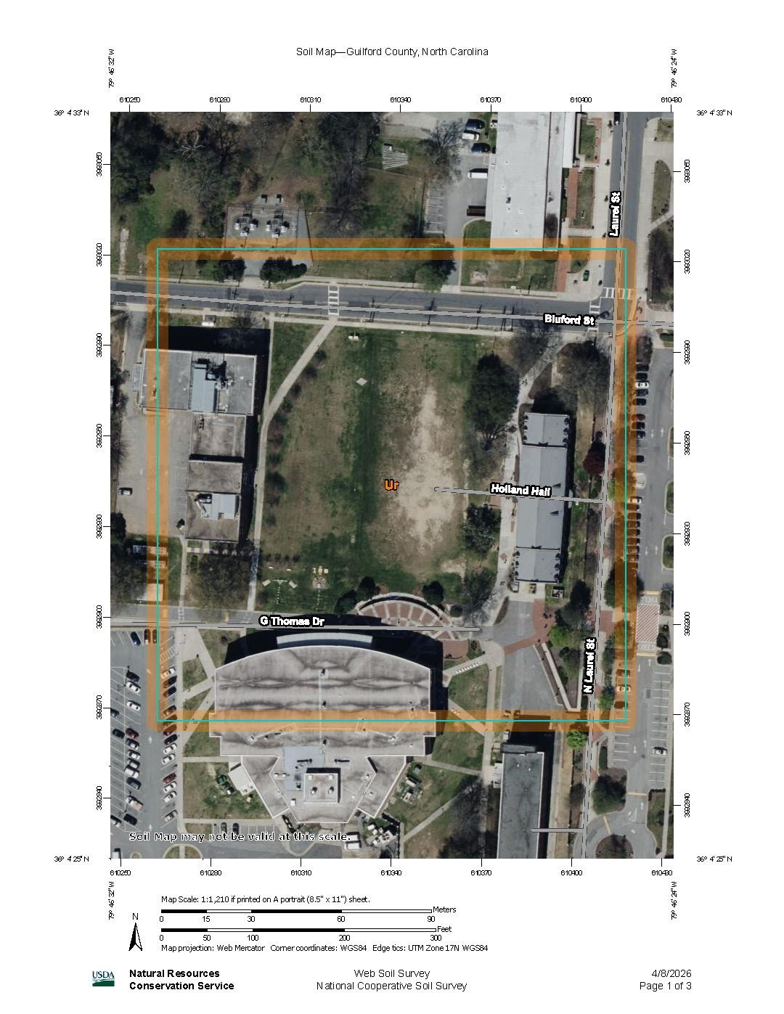
Figure 2. NRCS Web Soil Survey classification for the Holland Bowl area of interest, showing Urban Land (anthropogenic fill) designation. Data from USDA-NRCS Web Soil Survey (NRCS, n.d.).
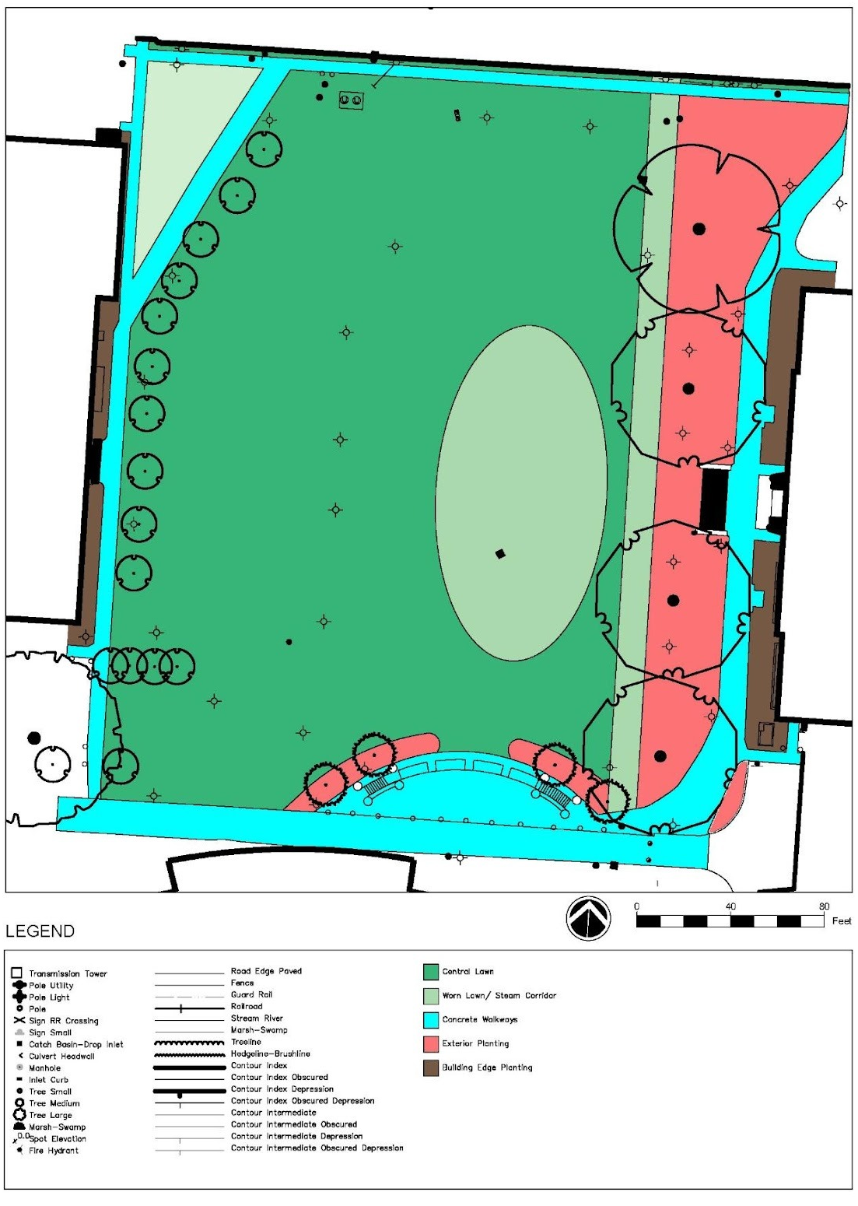
Figure 3. Holland Bowl site analysis: vegetation assessment zones, specimen inventory, and infrastructure constraints. Diagram by the authors.
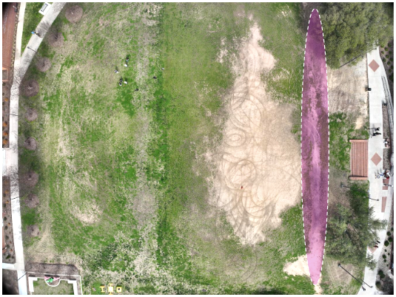
Figure 4. Steam vent corridor at the Holland Bowl, visible as a linear zone of persistent turf dieback approximately three meters wide. Photo by the authors.

DISCUSSION

SITES as a Structuring Framework for Landscape Digital Twins
The most transferable contribution of this research is the demonstration that sustainability rating systems—specifically SITES v2—can function as structured data collection frameworks for landscape digital twins, not merely as post hoc evaluation tools. The SITES prerequisite and credit structure provides a systematic checklist of what information a landscape baseline requires, at what resolution, and for what purpose. This contrasts with the opportunistic data aggregation characterizing most existing landscape digital twin efforts (Ye et al., 2023; Horvath & Pouliou, 2024). Other institutions need not reinvent the data specification process: the SITES framework provides a publicly available, externally validated structure that can be mapped directly to data collection requirements.

Soil and Vegetation Findings as Design Implications
The NRCS Urban Land classification carries implications beyond this specific site (NRCS, n.d.). Many campus landscapes—particularly those constructed or regraded during mid-twentieth century university expansion—occupy anthropogenic fill rather than native soil (Pouyat et al., 2020). Design assumptions derived from native soil characteristics may be systematically inappropriate, leading to planting failures, drainage problems, and SITES outcomes that do not reflect actual conditions. When the soil classification and vegetation baseline are considered together, they reveal a compounding condition—high-maintenance vegetation growing in anthropogenic fill—that conventional management has perpetuated rather than addressed (GBCI, 2014; Tallamy, 2007). The digital twin makes this compound condition legible by presenting both data layers simultaneously, allowing students to see the interaction of constraints as a design opportunity with measurable improvement potential.

Undergraduate Researchers as Co-Investigators
Jordan Canal’s steam vent corridor discovery warrants discussion as evidence for the value of undergraduate researchers as active co-investigators. The finding was produced by an observer physically present on site who noticed an anomalous pattern and followed an investigative instinct—precisely the kind of tacit, embodied site knowledge that design education aims to develop (Schön, 1983). Because students of color frequently report lower scientific confidence and perceive significantly less support from professors compared to their white peers (Parris et al., 2024), structured mentorship interventions are critical. The Evans-Allen-funded research assistant model provides this structured support: mentored field experience, co-authorship opportunities, and integration into a research team pursuing questions with real institutional consequences.

Limitations
This work is limited to a single site baseline and does not constitute validation across diverse sites. UAV imagery processing and expanded inventories are ongoing or planned for summer 2026; reported baseline findings should be interpreted as the initial evidence base for a SITES-structured workflow rather than a comprehensive site evaluation. The AI-assisted site analysis is presented as a proof-of-concept tool demonstration.

CELA 2026 Conference Feedback
Presentation of this work at CELA 2026 generated a critique common to practice-based research: rigorous scholarship requires an explicit theoretical framework. In responding to that critique, the team identified Schön's (1983) reflective practice theory as already embedded in the project's structure—in the SITES-as-feedback-loop argument, in the pedagogical objectives, and in the iterative development of AVA itself—a process of recognition that aligns with Schön’s concept of reflective practice, where understanding emerges through engagement.
A review of relevant literature—CELA proceedings, applications of digital twins, pedagogical applications of GIS, and design studio education—confirmed that while reflective exercises and reflection-in-action are widely present as pedagogical tools in landscape architecture, Schön's framework has not been explicitly applied to landscape digital twin methodology. This paper's contribution is not the first application of reflective practice to landscape pedagogy, but may be among the first explicit theoretical naming of it within the landscape digital twin context.

CONCLUSION
This paper has documented the construction of a SITES-structured digital twin data foundation for the Holland Bowl at NC A&T State University, an Evans-Allen-funded initiative bridging landscape architecture education and applied campus planning at an HBCU. The core methodological contribution is the demonstration that SITES v2 can serve as a structured data specification for landscape digital twin construction—determining what to collect, where, and at what resolution—rather than functioning only as a post hoc evaluation tool. This approach is replicable: any institution can map SITES prerequisites to data collection requirements and produce a purposeful, performance-oriented digital twin foundation.
The Evans-Allen program's capacity-building mandate is served not only by the research outputs but by the research process itself: an undergraduate researcher produced a field finding no computational workflow could replicate, earned co-authorship at a national conference, and developed integrated site knowledge—simultaneously digital and embodied—that the profession increasingly demands.
The architecture established here is the foundation for what AVA is becoming: a system in which georeferenced field data and site imagery are ingested directly against SITES criteria to generate a performance baseline, and upon which proposed design interventions can be evaluated in near-real-time against certification thresholds. This vision evolved as the project progressed, as new AI capabilities emerged, and as the threshold for building these tools dropped low enough that the gap between manual site assessment and criteria-based scoring became closeable. AVA is the glue: it does not replace the site visit or the rating system, but bridges the distance between them so that performance feedback can enter the design process at the moment it is most useful. The pedagogical interface, participatory science architecture, and generative AI integration that build upon this data foundation are the subject of ongoing development and will be documented in subsequent research (Figure 5).
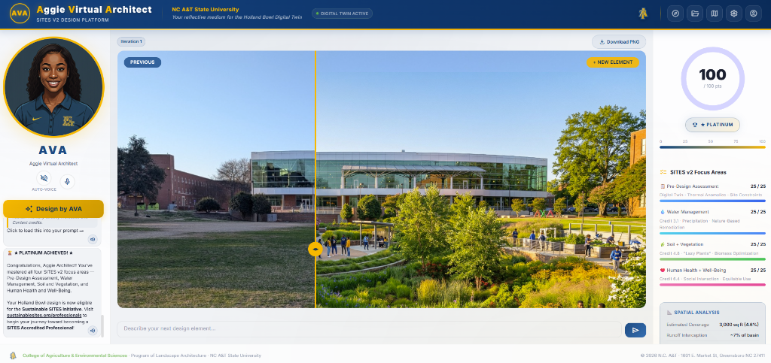
Figure 5. The Aggie Virtual Architect (AVA) interface prototype, showing the three-column pedagogical layout: AI design assistant with voice interaction (left), generative design canvas displaying the Holland Bowl (center), and SITES v2 real-time scoring dashboard with radial gauge and spatial analysis (right). The interface operationalizes the data foundation documented in this paper. Screenshot by the authors.

REFERENCES
Batty, M. (2018). Digital twins. Environment and Planning B: Urban Analytics and City Science, 45(5), 817–820. https://doi.org/10.1177/2399808318796416
Biljecki, F., Stoter, J., Ledoux, H., Zlatanova, S., & Çöltekin, A. (2015). Applications of 3D city models: State of the art review. ISPRS International Journal of Geo-Information, 4(4), 2842–2889. https://doi.org/10.3390/ijgi4042842
Calkins, M. (2012). The sustainable sites handbook: A complete guide to the principles, strategies, and best practices for sustainable landscapes. Wiley.
Chen, H., Shao, H., Deng, X., Wang, L., Wang, X. (2024). Comprehensive Survey of the Landscape of Digital Twin Technologies and Their Diverse Applications. Computer Modeling in Engineering & Sciences, 138(1), 125–165. https://doi.org/10.32604/cmes.2023.027834
Colomina, I., & Molina, P. (2014). Unmanned aerial systems for photogrammetry and remote sensing: A review. ISPRS Journal of Photogrammetry and Remote Sensing, 92, 79–97. https://doi.org/10.1016/j.isprsjprs.2014.02.013
Ecopia AI. (n.d.). Land cover & land use mapping data | 2D & 3D map data. Retrieved December 2025, from https://www.ecopiatech.com/products/3d-land-cover
George, B., & Park, K. (2020). Flying High: A Case Study of the Integration of Drones into a Landscape Architecture Curriculum. 5. 246-253. https://doi.org/10.14627/537690026
Green Business Certification Inc. (2014). SITES v2 rating system: For sustainable land design and development. Green Business Certification Inc.
Grieves, M. (2014). Digital twin: Manufacturing excellence through virtual factory replication [White paper]. Michael W. Grieves, LLC.
Han, S., Jiang, Y., Huang, Y., Bai, Y., Wang, M., & Spool-White, A. (2023). Scan2Drawing: Use of deep learning for as-built model landscape architecture. Journal of Construction Engineering and Management, 149(5), 04023027. https://doi.org/10.1061/JCEMD4.COENG-13077
Horvath, A.-S., & Pouliou, P. (2024). Digital Twins in Architecture: An ecology of practices and understandings. In Z. Lv (Ed.), Handbook of Digital Twins (1 ed., pp. 662-686). CRC Press. https://doi.org/10.1201/9781003425724-46
International Society of Arboriculture. (n.d.). International Society of Arboriculture. Retrieved April 2026, from https://www.isa-arbor.com/
National Academies of Sciences, Engineering, and Medicine. (2024). Foundational research gaps and future directions for digital twins. The National Academies Press. https://doi.org/10.17226/26894
Parris, K. J., Leggett, Z. H., & Spence, P. L. (2024). Undergraduate students’ confidence in scientific activity and support systems based on diversity in an environmental science course. American Journal of Undergraduate Research, 21(1). https://doi.org/10.33697/ajur.2024.113
Pouyat, R. V., Day, S. D., Brown, S., Schwarz, K., Shaw, R. E., Szlavecz, K., Trammell, T. L. E., & Yesilonis, I. D. (2020). Urban soils. In R. V. Pouyat, M. A. Callaham, D. D. Richter, & K. Gaines (Eds.), Forest and rangeland soils of the United States under changing conditions (pp. 127–144). Springer. https://doi.org/10.1007/978-3-030-45216-2_7
Ramirez Aranda, N., De Waegemaeker, J., & Van de Weghe, N. (2023). The evolution of public participation GIS (PPGIS) barriers in spatial planning practice. Applied Geography, 155, 102940. https://doi.org/10.1016/j.apgeog.2023.102940
Schön, D. A. (1983). The reflective practitioner: How professionals think in action. Basic Books.
Shahat, E., Hyun, C. T., & Yeom, C. (2021). City Digital Twin Potentials: A Review and Research Agenda. Sustainability, 13(6), 3386. https://doi.org/10.3390/su13063386
Sleipness, O. R., & George, B. H. (2017). Impacts of immersive virtual reality on three-dimensional design processes: Opportunities and constraints for landscape architecture studio pedagogy. Landscape Research Record, 6, 2–10.
Small Unmanned Aircraft Systems, 14 C.F.R. § 107 (2016).
Summerlin, P., George, B., & Bailey, S. (2024). The digital palette: A survey of current software integration in landscape architecture curricula. Landscape Research Record, 13, 35-47.
Tallamy, D. W. (2007). Bringing nature home: How you can sustain wildlife with native plants. Timber Press.
U.S. Geological Survey. (n.d.). 3D Elevation Program (3DEP) lidar point clouds. Retrieved August 2025, from https://www.usgs.gov/3dep
USDA Natural Resources Conservation Service. (n.d.). Web soil survey. Retrieved March 2026, from https://websoilsurvey.nrcs.usda.gov
USDA National Institute of Food and Agriculture. (n.d.). Agricultural Research at 1890 Land-grant Institutions. Retrieved August 2025, from https://www.nifa.usda.gov/grants/programs/capacity-grants/agricultural-research-1890-land-grant-institutions
Weber, A. (2024). Representing complex sites: Exploring mobile LiDAR and thermal imaging as methods for documenting and analyzing landscapes. Landscape Research Record, 13, 2-12.
Ye, X., Du, J., Han, Y., Newman, G., Retchless, D., Zou, L., Ham, Y., & Cai, Z. (2023). Developing human‐centered urban digital twins for community infrastructure resilience: A research agenda. Journal of Planning Literature, 38(2), 187-199. https://doi.org/10.1177/08854122221137861

